Week 3 Task: Statistical Modeling and Hypothesis Testing
Project: Statistical Modeling of Student Performance Using Regression Analysis
Student Name: Sanika jaysing dorge Course/Internship: Data Science

Project Title
Statistical Modeling of Student Performance Using Regression Analysis Course / Internship: Data Science
Week: 3

Abstract
This project applies statistical modeling and hypothesis testing to a publicly available student performance dataset from the UCI Machine Learning Repository. The objective is to investigate whether weekly study-time category is associated with students’ final Mathematics grades. The analysis includes data cleaning, descriptive statistics, exploratory visualizations, Pearson correlation, multiple linear regression using Ordinary Least Squares (OLS), regression diagnostics, and held-out predictive evaluation. Numerical findings must be filled in from the accompanying notebook after running it. The study illustrates how statistical evidence can be used to assess relationships while acknowledging that observational data cannot establish causation.

Introduction
Statistical modeling helps identify relationships between variables and quantify uncertainty in data. Student academic performance may be related to study habits, attendance, previous grades, and past academic difficulties. This project uses Python to analyze these factors and build a model for final Mathematics grades.

Objectives
  - Load and inspect a public dataset.
  - Clean the data and calculate descriptive statistics.
  - Formulate and test a research hypothesis.
  - Fit a multiple linear regression model.
  - Examine model significance, R-squared, residual behavior, normality, constant variance, and multicollinearity.
  - Evaluate predictive performance on a held-out test set.
  - Discuss findings, limitations, and future improvements.

Dataset Description
The dataset is the Student Performance dataset published by the UCI Machine Learning Repository. The notebook uses the Mathematics file, `student-mat.csv`, which contains 395 records in its original form. The target variable is
`G3`, the final Mathematics grade on a 0–20 scale. Predictors include:
  - `studytime`: ordinal category for weekly study-time range (1–4).
  - `absences`: number of school absences.
  - `G1`: first-period grade.
  - `G2`: second-period grade.

  - `failures`: number of past class failures.
The exact shape after cleaning is printed by the notebook. Study-time categories are not exact hour measurements, and the category codes are treated as approximately equally spaced for this analysis.

Research Question and Hypotheses
Research question: Is weekly study-time category significantly associated with students’ final Mathematics grades? Null hypothesis (H): The population linear correlation between study-time category and final grade is zero (ρ = 0). Alternative hypothesis (H): The population linear correlation between study-time category and final grade is not
zero (ρ ≠ 0).
The significance level is α = 0.05. If the Pearson correlation p-value is below 0.05, the null hypothesis is rejected. Otherwise, the null hypothesis is not rejected because there is insufficient evidence of a linear association.

Methodology
- **Data loading:** The CSV dataset is read into a Pandas DataFrame.
- **Data cleaning:** Missing values and duplicate records are checked. Rows with missing values and duplicate rows are removed if present.
- **Exploratory data analysis:** Descriptive statistics and plots are created to inspect the final-grade distribution and relationships between selected variables.
- **Hypothesis testing:** Pearson correlation is calculated for `studytime` and `G3`, together with its p-value.
- **Regression:** An OLS multiple linear regression model predicts `G3` using `studytime`, `absences`, `G1`, `G2`, and `failures`.
- **Diagnostics:** Residual-versus-fitted and Q–Q plots are examined. The Shapiro–Wilk test checks residual normality, the Breusch–Pagan test checks for evidence of non-constant variance, and variance inflation factors (VIF) assess multicollinearity.
- **Predictive evaluation:** A reproducible 80/20 train-test split is used to calculate test R-squared, Mean Absolute Error (MAE), and Root Mean Squared Error (RMSE).

Results

Complete this section after running every cell in the attached notebook. Copy the real output values into the table.

Measure | Result
Number of records after cleaning | [Copy dataset shape]
Pearson correlation (r) | [Copy output]
Pearson correlation p-value | [Copy output]
OLS R-squared | [Copy model summary]
Adjusted R-squared | [Copy model summary]
Overall model F-test p-value | [Copy model summary]
Shapiro–Wilk p-value | [Copy output]
Breusch–Pagan p-value | [Copy output]
Test R-squared | [Copy output]
Test MAE | [Copy output]
Test RMSE | [Copy output]

The notebook also displays the regression coefficients and p-values for each predictor. Include the plots generated by the notebook in this section.

Interpretation
Interpret the actual results rather than assuming a particular outcome:
  - A positive Pearson correlation means higher study-time categories tend to be associated with higher final grades in this sample.
  - If the correlation p-value is below 0.05, reject H and report evidence of a statistically significant linear association. If it is 0.05 or higher, fail to reject H.
  - The OLS coefficient for `studytime` estimates the expected grade difference associated with a one-category increase, holding the other predictors constant.
  - R-squared describes the proportion of variation in final grades explained by the model on the fitted data. Adjusted R-squared accounts for the number of predictors.
  - Coefficient p-values assess evidence that individual regression coefficients differ from zero under the model assumptions.
  - Test-set MAE and RMSE summarize prediction errors in grade points. Test R-squared indicates predictive performance on unseen records and may be negative.
  - Residual patterns, diagnostic tests, and VIF values should be discussed. Statistical tests should not be interpreted as definitive proof that assumptions hold.

Limitations
  - The dataset is observational, so the results do not prove that study time causes higher grades.
  - `studytime` is ordinal; its categories do not represent exact hours or necessarily equal increments.
  - `G1` and `G2` may explain a large portion of final grades, but these prior grades may not be available for every intended prediction scenario.
  - Relevant factors such as motivation, teaching methods, home environment, and study quality may not be included.
  - Linear regression assumptions may not fully hold. Outliers, heteroscedasticity, non-normal residuals, or multicollinearity can affect inference.
  - A single train-test split can produce variable performance estimates.

Future Improvements
Future work could use cross-validation, robust standard errors, additional relevant variables, alternative ordinal or non-linear models, and a model excluding prior grades. Results could also be compared across the Mathematics and Portuguese datasets.

Conclusion
This project demonstrates how to perform statistical analysis using a public dataset and Python. It combines exploratory analysis, hypothesis testing, regression modeling, diagnostic checks, and predictive evaluation. The final conclusion must state whether the actual Pearson correlation p-value supports rejecting the null hypothesis at the 0.05 significance level. The conclusion should also summarize the regression performance and any important diagnostic concerns. Because the dataset is observational, findings should be described as associations rather than causal effects.

References
- Cortez, P., & Silva, A. (2008). *Using data mining to predict secondary school student performance*. Proceedings of the 5th Future Business Technology Conference (FUBUTEC).

- UCI Machine Learning Repository. *Student Performance Data Set*. https://archive.ics.uci.edu/dataset/320/student+performance
- pandas documentation. https://pandas.pydata.org/docs/
- statsmodels documentation. https://www.statsmodels.org/
- scikit-learn documentation. https://scikit-learn.org/stable/
- SciPy documentation. https://docs.scipy.org/doc/scipy/

Appendix: Code
The complete reproducible Python code is provided in the accompanying `Week_3_Statistical_Modeling.ipynb` file.

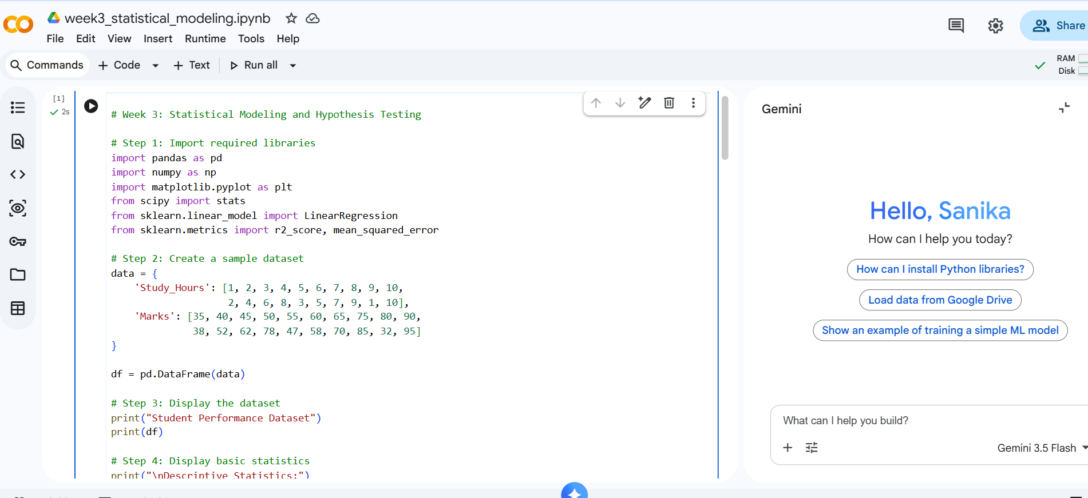

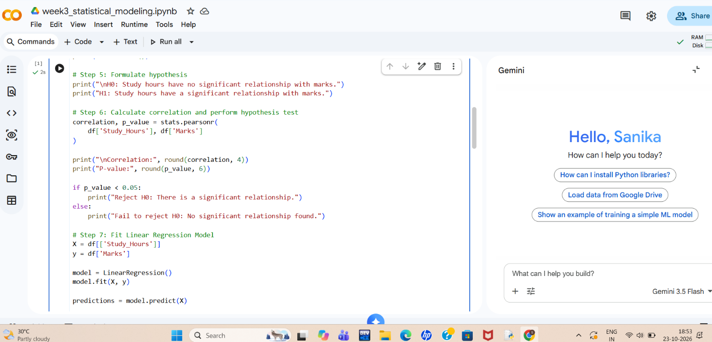

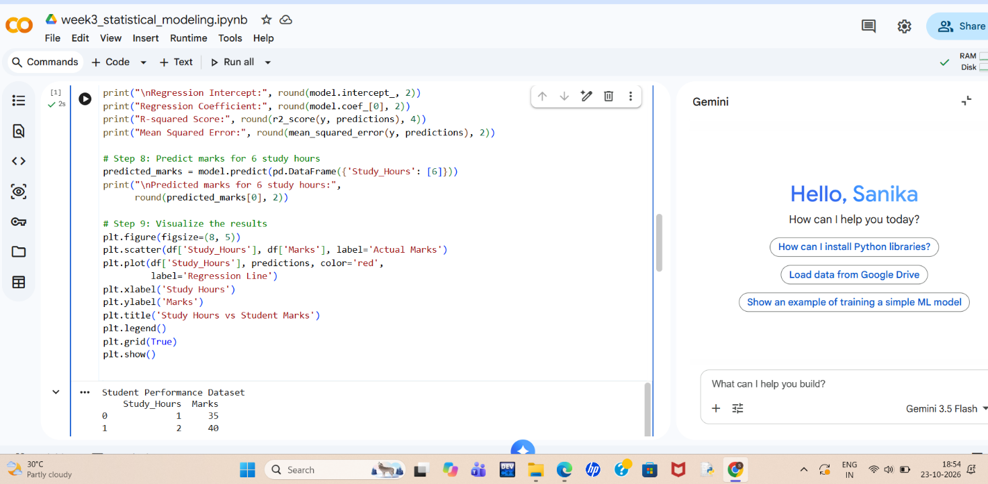

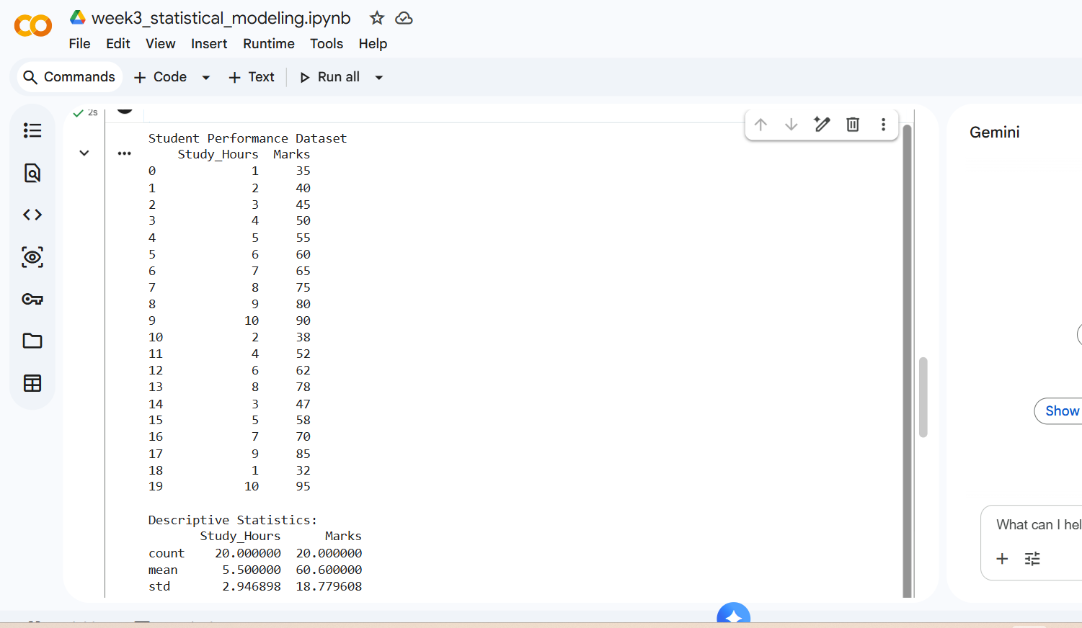
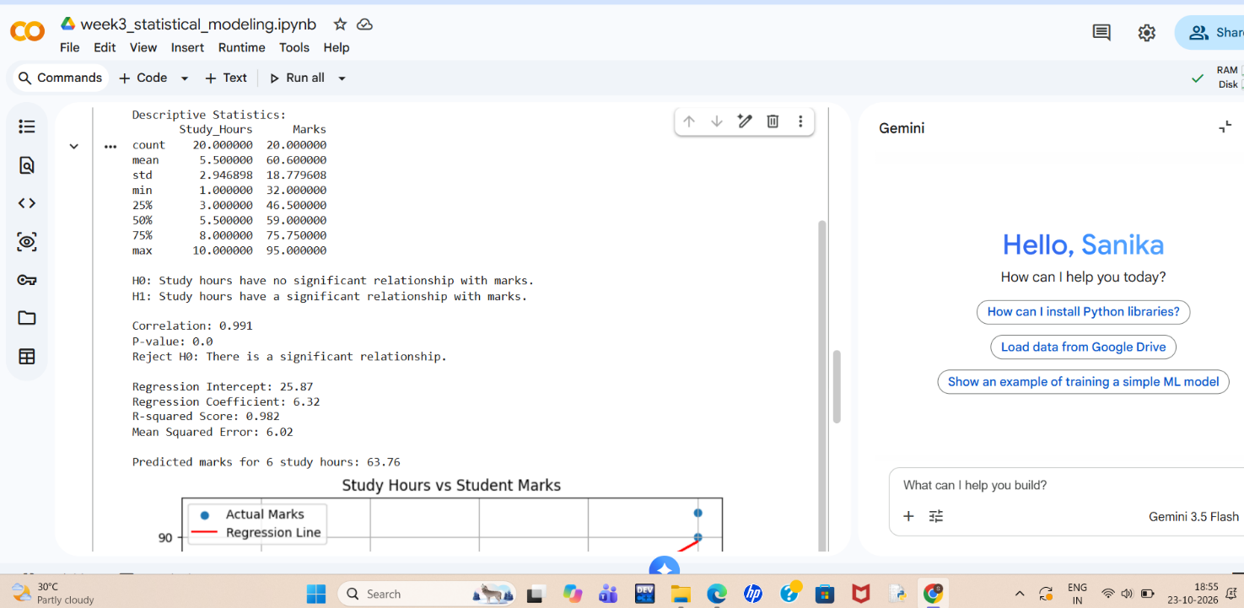

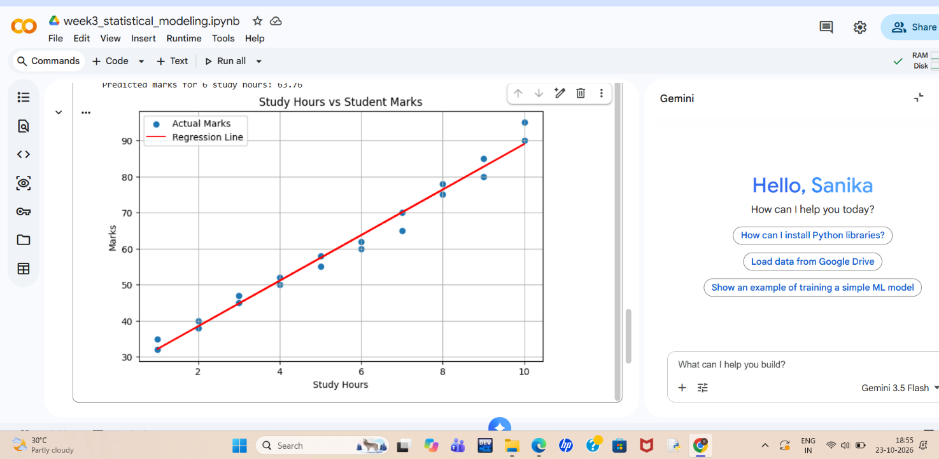
Graphical Representation
Graph Title: Study Hours vs Student Marks
Graph Type: Scatter Plot with Linear Regression Line
X-axis: Study Hours (independent variable)
Y-axis: Marks Obtained (dependent variable)
Description:
The graph represents the relationship between the number of hours students study and the marks they obtain. The scatter plot shows the actual data points, while the red regression line represents the predicted relationship obtained using the Linear Regression model.
The graph shows a positive linear relationship between study hours and marks. As study hours increase, students' marks generally increase. The regression line helps visualize this trend and estimate marks based on study hours.

plt.scatter(df['Study_Hours'], df['Marks'], label='Actual Marks')
plt.plot(df['Study_Hours'], predictions, color='red',
label='Regression Line')
plt.xlabel('Study Hours')
plt.ylabel('Marks')
plt.title('Study Hours vs Student Marks')
plt.legend()
plt.grid(True)
plt.show()
Result
The graph indicates a strong positive association between study hours and marks in the sample dataset. This supports the hypothesis-testing result, although the relationship does not by itself prove that studying longer causes higher marks.

